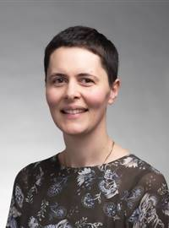 | Sarah Edwards  Lincoln University  I am a Lecturer in the Department of Environmental Management at Lincoln University. I am the academic co-ordinator of postgraduate qualifications in Environmental Management, and I teach core courses in the department’s undergraduate and postgraduate degree programmes.  In my research I use conceptual tools from the field of Science and Technology Studies (STS) to study environmental management issues. In my PhD I examined the risk management of research into genetically modified organisms in New Zealand. More recently I have worked on a project exploring the role of science advisors in freshwater governance in the Canterbury region. I have also conducted research on urban risk and resilience in the context of the Canterbury earthquakes, including a recently completed project within National Science Challenge 11: Building better homes, towns and cities.  Prior to embarking on an academic career I worked as a High School science teacher for a number of years, and I have taught in schools in the UK, Japan and New Zealand. I have an honours degree in Psychology from the University of Nottingham, undertook my teacher training at the University of London, and have a PhD in Environmental Management from Lincoln University.  I have held a part-time position at Lincoln since 2017. Outside work I spend my time with my young daughter, preferably at the beach or out for a walk.

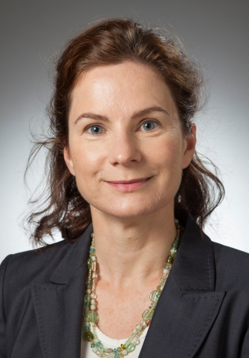 | Deirdre Hart  University of Canterbury  I lecture in coastal science and geography, and coordinate the Masters in Urban Resilience and Renewal in Te Kura Aronukurangi, the School of Earth and Environment, UC. Also, I am one of the UC Proctors (student integrity and behaviour). Teaching for me is a joyful activity, full of new insights and ideas with each new student cohort.  My key research foci include multi-hazards; river mouth lagoons and other coastal hydrosystems; coastal hazards including climate change effects; and tides and related ocean processes. I find working across disciplinary boundaries exciting and enriching: I work closely with engineers, planners, ecologists, oceanographers, and community engagement specialists, amongst others.  My degrees are from UC (BSc hons, MSc) and UNSW (PhD).  I have a 9 year old daughter, Ella, and enjoy gardening, walking and reading.
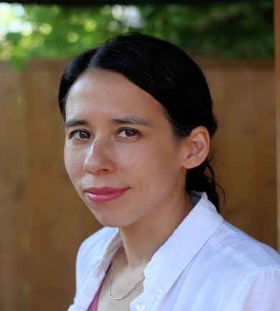 | Simone Larcher  University of Canterbury  I am a Lecturer in the Civil and Natural Resources Engineering (CNRE) Department at UC. I currently teach into two undergraduate courses: Environmental Engineering and Ecological Engineering.  My research interests broadly consist of water/wastewater treatment and soil / groundwater remediation. I am particularly interested in the removal of emerging contaminants and endocrine disrupting compounds (i.e. antibiotics, synthetic oestregens, pharmaceuticals and personal care products, PFAS compounds etc.) that typically persist in treated wastewater effluent and are thus discharged into the receiving environment. My research has evolved from advanced drinking water disinfection (i.e. ozone) to include applied microbiology and impacts on toxicity/estrogenicity. My aim is to develop more effective low-impact strategies to reduce/degrade these types of persistent contaminants by harnessing the abilities of microorganisms.  I have a BASc and MASc in Civil/Environmental Engineering from the University of Toronto, and I was a post-doc/research associate in this department after completing my PhD in Chemical Engineering at McGill University. Prior to pursuing my doctorate, I worked in engineering consulting as a process design engineer (water and wastewater) and in R&D for a water utility, which enabled me to become a licensed professional engineer in the province of Ontario (Canada).  I currently enjoy going to the beach with my family (husband, young daughter and dog), cooking, baking and listening to music/having dance parties. I look forward to finding the time to play the piano, read books that are not intended for children and are completely unrelated to engineering, and participate in activities that I used to love (tennis, cycling, snowboarding/skiing, volleyball).
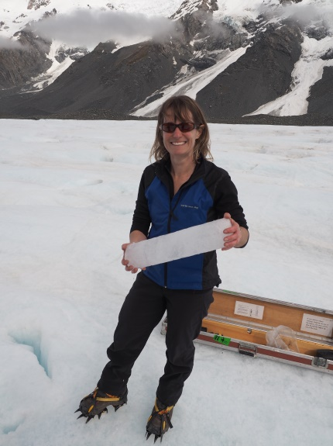 | Heather Purdie  University of Canterbury  I am a Senior Lecturer in physical geography with expertise in glaciology. Geography is all about te tāngata me to whenua, people and the land. To care for Te Ao (Earth) we need not only to understand how natural systems work, but to also understand people’s interactions with those systems. My research interests span from process studies that explore feedbacks between glacier mass balance and climate, to examining the implications of current glacial recession on people’s alpine experiences through tourism and recreation. I have ongoing field projects on Fox, Tasman and Rolleston Glaciers.  As an experimental educator, I love developing class-based and field activities that ignite students’ curiosity about the natural environment, and am currently involved in an Ako project exploring the value of students using their own devices in fieldwork.  I combine my study of natural process and glaciology (PhD, 2011, VUW), with teaching scholarship (Grad. Dip. Teaching & Learning, PG Cert. Tertiary Teaching), and just this year completed a Diploma in Language in Te Reo Māori.  I enjoy climbing and tramping; pastimes that also help inform my contribution as a member on the Canterbury Aoraki Conservation Board, and making sure the ongaonga and tikumu all have space in my garden.
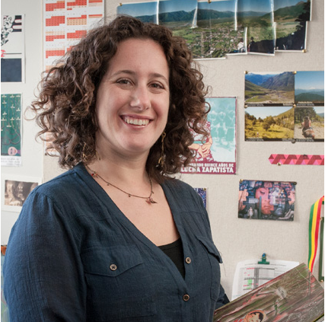 | Marcela Palomino-Schalscha  Victoria University of Wellington  I am a Senior Lecturer in Human Geography and Development Studies at VUW, where I have been working since 2012 after completing my PhD (Canterbury University).  I am originally from Chile, where I mainly worked in rural areas for environmental and community development NGOs. Those experiences inspired me to do my PhD and shaped my academic career, where I have worked closely with communities both in Chile and Aotearoa.  From feminist, post-colonial and participatory perspectives, my research focuses on diverse and solidarity economies, political ecology, Indigenous rights and the politics of place and scale. Most of my work has been on the ways in which Indigenous tourism can be used as a tool for self-determination and cultural, economic and political autonomy. More recently, I have been working with embodied, visual and textile methods and street art to explore belonging and place-making with migrant and former refugee communities. I am a founder and leader of The Wellington Arpilleras Collective, a group of Latin American migrant and former refugee women that creates arpilleras, a form of political tapestry from Latin America. I am also a founder of The Latin Collective, which brings together a wide range of Latinxs living in Aotearoa. In 2019 our main achievement was creating a community-based Latin American mural in Newtown to celebrate diversity and counter racism.  I have two daughters. I love sewing, going to the beach, and doing creative stuff with others.
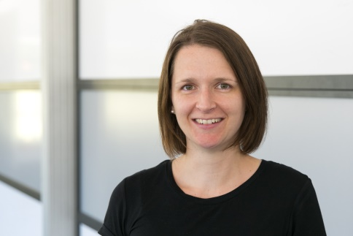 | Shari Gallop  University of Waikato  I am a physical marine scientist focused on the coast and nearshore, including oceanography, sediment transport and geomorphology. I work in a range of marine environments, on a spectrum of spatial (mm to 1000’s of km) and temporal (s to decades) scales, including in estuaries, open coast beaches, coral reefs and rock coasts. I use a range of techniques such as in situ field measurements, combined with remote sensing techniques (e.g. video) and numerical hydrodynamic and morphodynamic modelling to understand relationships between meteorological, hydrodynamic, and geological processes.  I also have a strong track recovery in community education and engagement, including mainstream media such as BBC Coast New Zealand. I am a founding committee member of Women in Coastal Geoscience and Engineering and Associate Editor for Anthropocene Coasts.  I have a PhD, MSc (Hons), BSC and work as a Senior Lecturer in the School of Science at the University of Waikato.
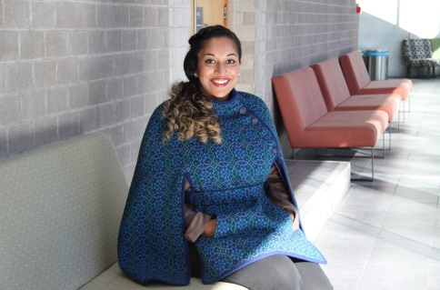 | Sandeeka Mannakkara  University of Auckland  Sandeeka is a University of Auckland graduate, who started her career as a structural engineer and then proceeded to earn her PhD at the University of Auckland's department of civil and environmental engineering. She specialises in post-disaster recovery and reconstruction, city resilience and climate change adaptation. She has been working as a Research Fellow on a number of Government-funded projects following her PhD, and started her new role as Lecturer in Climate Engineering at UoA’s department of civil and environmental engineering this year.  Outside of work matters of importance to her are family, friends, equity and diversity. Her hobbies include music, reading, art, travel, dogs, tv shows and movies. She enjoys going to the gym, yoga, meditation and cooking.

